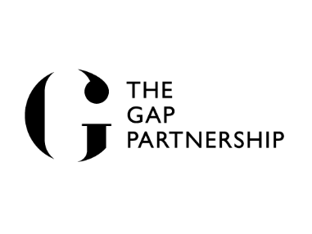
MODERN SLAVERY AND
HUMAN TRAFFICKING STATEMENT

INTRODUCTION
The Gap Partnership Limited is making a modern slavery and human trafficking statement relating to section 54 of Modern Slavery Act 2015.
We have a commitment to conducting business in a socially responsible and ethical manner and this extends to our commitment to continually improve our practices to combat slavery and human trafficking and ensure transparency within our business and throughout our supply chain.
The Gap Partnership sets out its principles how employees must conduct themselves to promote proper behaviour in its Employee Contracts, Handbooks and other documents issued from time to time that promote business ethics.

OUR BUSINESS
The Gap Partnership is the world's leading negotiation consultancy. We deliver negotiation consulting, training, skills workshops, strategy and planning services to global clients in the public, private and not-for-profit sectors. We have around 250 employees and operate in 60 countries.
This statement reflects The Gap Partnership's commitment to ethical trading principles and to set out the steps we are taking to tackle modern slavery and human trafficking in our business and in our supply chains. We see this as being integral to our corporate values, which include 'Being Trusted' and transparent as a business.

OUR ORGANISATIONAL STRUCTURE
Our Corporate Governance Framework consists of the Board of Directors and an operational management team. Our operational management team is responsible for decision making on economic, environmental and social issues and is operationally responsible for compliance with slavery and human trafficking issues.

OUR SUPPLY CHAINS
We have global suppliers that provide products and services including recruitment services, professional services, IT services and facilities support.

OUR POLICIES ON SLAVERY AND HUMAN TRAFFICKING
We are committed to ensuring that there is no slavery or human trafficking in our supply chains or in any part of our business. Our policies and practices reflect our commitment to acting ethically and with integrity in all our business relationships and to implementing and enforcing effective systems and controls to ensure slavery and human trafficking is not taking place anywhere in our supply chains.
Our employees are encouraged to report unlawful practices and concerns, and the following policies support our working practices:
- Whistleblowing Policy
- Health and Safety Policy

- Code of Conduct and Business Integrity Policy

DUE DILIGENCE PROCESSES FOR SLAVERY AND HUMAN TRAFFICKING
As part of our initiative to identify and mitigate risk we:
  - Select suppliers who share our commitment to high ethical standards
  - Identify and assess potential risk areas in our supply chains
  - Mitigate the risk of slavery and human trafficking occurring in our supply chains
  - Report slavery and trafficking abuses
  - Protect whistleblowers
  - Remove any suppliers found to have been involved in slavery and human trafficking in their operations from our supply chain

SUPPLIER ADHERENCE TO OUR VALUES AND ETHICS
We have zero tolerance to slavery and human trafficking. To ensure all those in our supply chain and contractors comply with our values we will take action in respect of any issues we identify or are made known to us.

TRAINING
To ensure a high level of understanding of the risks of slavery and human trafficking in our supply chains and our business, we provide training to our staff. We also request our business partners to provide training to their staff and suppliers and providers.

OUR EFFECTIVENESS IN COMBATING SLAVERY AND HUMAN TRAFFICKING
We aim to use the following key performance indicators (KPIs) to measure how effective we are to ensure that slavery and human trafficking is not taking place in any part of our business or supply chains:
- Cooperation from our suppliers in respect of compliance with their contractual obligations
- Numbers of investigations into our supply chain and action taken to improve compliance
- Interactions with our clients in working together to promote zero tolerance to slavery and human trafficking
- Numbers of employees receiving awareness training

This statement constitutes our slavery and human trafficking statement for the financial year ending 28 February 2027.

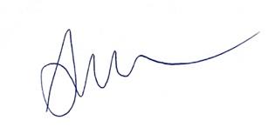 Date: 1 March 2026
Ann Marie Costelloe
Chief Executive Officer
The Gap Partnership Limited

